**MOVIE SUCCESS RATE PREDICTION**

**A PROJECT REPORT**

***Submitted by***

# VISHAL KUMAR SINGH

## (2019272041)

# MUKESH KUMAR PATEL

## (2019272025)

# ANJAN KUMAR

## (2019272004)

*A report for the project submitted to the Faculty of*

## INFORMATION SCIENCE & TECHNOLOGY

*in partial fulfillment for the award of thedegree*

***of***

**MASTERS**

***in***

**COMPUTER APPLICATION**



## DEPARTMENT OF INFORMATION SCIENCE AND TECHNOLOGY COLLEGE OF ENGINEERING, GUINDY

**ANNA UNIVERSITY CHENNAI 600 025**

**NOV 2020**

**ANNA UNIVERSITY CHENNAI - 600 025**

**BONA FIDE CERTIFICATE**

Certified that this project report titled MOVIE SUCCESS RATE PREDICTIONisthebonafideworkof VISHAL KUMAR SINGH, ANJAN KUMAR, MUKESH KUMAR PATEL who carried out project work under my supervision.Certified further that to the best of my knowledge and belief, the work reported herein does not form part of any other thesis or dissertation on the basis of which a degree or an award was conferred on an earlier occasion on this or any other candidate.

**PLACE: DATE:**

*MR.H.RIASUDHEEN*

*Teaching Fellow*

**PROJECT GUIDE DEPARTMENT OF IST, CEG ANNA UNIVERSITY CHENNAI 600025**

**COUNTERSIGNED**

**Dr. SASWATI MUKHERJEE HEAD OF THE DEPARTMENT**

**DEPARTMENT OF INFORMATION SCIENCE AND TECHNOLOGY COLLEGE OF ENGINEERING, GUINDY**

**ANNA UNIVERSITY CHENNAI 600025**

# ABSTRACT

In this system have developed a mathematical model for predicting the success class such as flop, hit, super hit of the movies. For doing this we had to develop a methodology in which the historical data of each component such as actor, actress, director, music that influences the success or failure of a movie is given is due to weight age and then based on multiple thresholds calculated on the basis of descriptive statistics of dataset of each component it is given class flop, hit, super hit label. Admin will add the film crew data. Admin will add movies data of a particular film crew. Admin will add new movie data along with film crew details as well as release date of the new movie. Based on the weight age of historical data of each film crew the movie will be labeled as super hit, hit or flop. This system helps to find out whether the movie will be super hit, hit, flop on the basis of historical data of actor, actress, music director, writer, director, marketing budget and release date of the new movie.

# ACKNOWLEDGEMENT

Acknowledgement should be brief and should not exceed one page when typed in one and a half line spacing.

# TABLE OF CONTENTS

ABSTRACT iii

LISTOFTABLES vii

LISTOFFIGURES viii

LIST OF SYMBOLSANDABBREVIATIONS ix

1. INTRODUCTION 1
   1. FORMAT OFTHETHESIS 1
      1. TableofContents 1
      2. List of TablesandFigures 1
      3. List of SymbolsandAbbreviations 2
      4. Chapters 2
      5. Appendices 2
      6. References 3
      7. Citation 3
      8. TablesandFigures 3
   2. TYPINGINSTRUCTIONS 4
      1. General 4
      2. Chapter 4
   3. NUMBERINGINSTRUCTIONS 5
      1. PageNumbering 5
      2. Numbering of Chapters, DivisionsandSubdivisions 5
         1. A subdivision ofthesubsection 6
      3. Numbering of TablesandFigures 6
      4. NumberingofEquations 6
2. LITERATURESURVEY/RELATEDWORK 7
   1. METHODOFCITATION 7
      1. Approachof Waldron 7
      2. ApproachbyConley 7
      3. Anotherapproach 7
   2. SECTION2 7
      1. Subsection1 8
      2. Subsection2 8
   3. SECTION3 8
      1. Subsection1 8
      2. Subsection2 8
3. YOUR WORKBASEDTITLE 9
   1. VIEWOFTABLES 9
   2. VIEWOFFIGURES 9
   3. VIEWOFEQUATIONS 9
4. DESIGN/ PSEUDOCODE/ALGORITHMS/LOGIC 11
   1. ALGORITHM1 11
5. IMPLEMENTATION/ RESULTS ANDANALYSIS 12
6. COMPARISON 13
7. CONCLUSION ANDFUTUREWORK 14

APPENDIX 15

1. TOPIC1 15
   1. SECTION1 15
   2. SECTION2 15
2. TOPIC2 16
   1. SECTION1 16
   2. SECTION2 16

REFERENCES 17

**INTRODUCTION**

Movies is the most convenient way to entertain peoples. However only few movies get higher success and are ranked high. Many movies are produces by the movie industry in a year. A movie revenue depends on various components such as cast acting in a movie, budget for the making of the movie, film critics review, rating for the movie, release year of the movie, etc. Because of these multiple components there is no formula that helps us to provide analysis for predicting how much revenue a particular movie will be generating. However by analyzing the revenues generated by previous movies, a model can be built which can help us predict the expected revenue for a particular movie. As we know in today’s world the movie is one of the biggest source of entertainment and also for business purposes. . To expend this business further we need the technology through which we can predict the success rate of the movie. If we were able to predict the movie success rate in the correct manner then it will be easy for the businessman to get higher profit from it and also if the prediction shows the success rate is low of certain movie then it helps those businessmen to improve the content of the movie so that they can get higher revenue from it. success rate of movies, models and mechanisms can be used to predict the success of a movie. It will help the business significantly. stakeholders such as actors, producers, directors etc. can use these predictions to make more informed decisions. They can make the decision before the movie release. This proposed work aims to develop a model based upon the data mining techniques that may help in predicting the success of a movie in advance thereby reducing certain level of uncertainty. The excellent way to find detailed information about almost every film ever made is through IMDb. Vast amount of data, which contains much valuable information about general trends in films. Data mining techniques enable us to uncover information which will both confirm or disprove common assumptions about movies, and also allow us to predict the success of a future film given select information about the film before its release. So here we are developing the software for data analytics through which we can predict the success rate of the movie which high accuracy. Here we are using the R-software to predicting the movie success rate into which first we have downloaded the data set from kaggle.com and after that we are generating the training and test data set. In a dataset, a training set is implemented to build up a model, while a test (or validation) set is to validate the model built.

**DATA COLLECTION**

The crude IMDb dataset is organized so that the greater part of its properties and information is sorted out and put away independently in compacted plain content documents. For example, the majority of the approximately 651 movies picture appraisals from the database are put away in the compacted content document evaluations. Rundown which incorporates literary informationabout the information just as a table of film rank, the number of votes and film titles. In this way, some kind of cleaning, mix and preprocessing is probably going to be required so as to utilize the information with the end goal of information mining through

supervised machine learning strategies. The information was gathered utilizing IMDB which contains the IMDB motion picture dataset of in excess of 651 films in the dataset.

**DATA PREPROCESSING**

In this stage dataset is prepared for applying data mining technique. Before applying data mining technique, pre-processing methods like cleaning, variable transformation and data partitioning and other techniques for attribute selection must be applied. After pre-processing we have attributes or variables for each movie. Each test file will contain best attributes and rebalanced. As the data is taken in the raw format from IMDb it is first required to be pre-processed. To overcome missing value scenario central tendency method is used both mean and median and later the duplicate items are removed. Pre-processing is the crucial phase for the project as it mainly focuses on the working of the algorithm. As the data is now pre-processed next comes data integration and transformation in which the alpha numerical data need to be converted to the numerical data as it is required for regression model. The correlation between the features is identified using the greedy backwards method.

**Client Side**

**ARCHITECTURE**

CSV dataset

RSCRIPT

Output

Search attributes

PREDICTION

SEARCH

**Server Side**

**CODES**

**index.html**

<!DOCTYPE html>

<html>

<head>

<title>movie success 2020</title>

<link rel="stylesheet" type="text/css" href="style.css">

<link rel="stylesheet" type="text/css" href="index.css">

<link href="https://fonts.googleapis.com/css?family=Dosis" rel="stylesheet">

</head>

<body>

<header>

<div class="header_menu">

<div class="logo">

<a href="index.html"><img src="images/logo.png" alt="movie success"></a>

</div>

<!-- admin tab

<div class="menu_list">

<ul>

<li><a href="login.html">Admin</a></li>

</ul>

</div>

-->

</div>

<div class="header_content">

<h2>RATING / SUCCESS / PREDICT</h2>

<h1>MOVIE SUCCESS</h1>

<button><a href="index2.html">

Lets Get Started

</a></button>

</div>

</header>

</body>

</html>

**Index.css**

*{

padding: 0;

margin: 0;

}

.header_content{

text-transform: uppercase;

width: 100%;

height: 200px;

position: absolute;

top: 50%;

left: 50%;

color:rgba(255, 255, 255, .8);

transform: translate(-50%, -50%);

text-align: center;

}

.header_content h2{

margin-bottom: 50px;

font-size: 17px;

font-weight: 500;

letter-spacing: 0.3em;

transition: 0.4s;

}

header{

width: 100%;

height: 100vh;

background-image: url('images/background.jpg');

background-size: cover;

font-family: 'Dosis', sans-serif;

}

.header_content h1{

margin-bottom: 50px;

font-size: 50px;

font-weight: 500;

letter-spacing: 0.7em;

transition: 0.4s;

}

.header_content button{

height: auto;

padding:8px 37px;

color:#fff;

font-size: 12px;

background-color: transparent;

margin-right: 20px;

transition: 0.5s;

}

.header_content button a{

text-transform: uppercase;

text-decoration: none;

color: white;

letter-spacing: 1px;

}

.header_content button:hover{

background-color:#ffc107;

border:1px solid white;

}

**Index2.html**

*{

padding: 0;

margin: 0;

}

.header_content{

text-transform: uppercase;

width: 100%;

height: 200px;

position: absolute;

top: 50%;

left: 50%;

color:rgba(255, 255, 255, .8);

transform: translate(-50%, -50%);

text-align: center;

}

.header_content h2{

margin-bottom: 50px;

font-size: 17px;

font-weight: 500;

letter-spacing: 0.3em;

transition: 0.4s;

}

header{

width: 100%;

height: 100vh;

background-image: url('images/background.jpg');

background-size: cover;

font-family: 'Dosis', sans-serif;

}

.header_content h1{

margin-bottom: 50px;

font-size: 50px;

font-weight: 500;

letter-spacing: 0.7em;

transition: 0.4s;

}

.header_content button{

height: auto;

padding:8px 37px;

color:#fff;

font-size: 12px;

background-color: transparent;

margin-right: 20px;

transition: 0.5s;

}

.header_content button a{

text-transform: uppercase;

text-decoration: none;

color: white;

letter-spacing: 1px;

}

.header_content button:hover{

background-color:#ffc107;

border:1px solid white;

}

**Predict.html**

<!DOCTYPE html>

<html>

<head>

<title>movie success 2020</title>

<link rel="stylesheet" type="text/css" href="style.css">

<link rel="stylesheet" type="text/css" href="index.css">

<link href="https://fonts.googleapis.com/css?family=Dosis" rel="stylesheet">

</head>

<style>

.header_content h2{

font-size:200%;

}

.table-content{

margin-left: auto;

margin:auto;

}

.table-content td{

text-align: left;

padding: 5px 20px;

transition: 0.8s;

}

.table-content input{

width: auto;

}

#btn{

padding: 10px 30px;

background-color: black;

color: white;

}

#btn:hover{

background-color:#ffc107;

cursor: pointer;

transition: 0.8s;

}

</style>

<body>

<header>

<div class="header_menu">

<div class="logo">

<a href="index.html"><img src="images/logo.png" alt="movie success"></a>

</div>

<div class="menu_list">

<ul>

<li><a href="login.html">Admin</a></li>

</ul>

</div>

</div>

</header>

<form>

<div class="header_content">

<h2> PROCEED NEXT FOR RATING</h2>

<table class="table-content">

<tr>

<td><label>MOVIE-NAME</label></td>

<td><input type="text" class="text-input" id="movie-name" placeholder="" autocomplete="off" ></input></td>

<td rowspan="5"><input type="submit" id="btn" value="NEXT"></input></td>

</tr>

<tr>

<td><label>GENRE</label></td>

<td><input type="text" class="text-input" id="genre" placeholder="" autocomplete="off" ></input></td>

</tr>

<tr>

<td><label>STAR-CAST</label></td>

<td><input type="text" class="text-input" id="star-cast" placeholder="" autocomplete="off"></input></td>

</tr>

<tr>

<td><label>DIRECTOR</label></td>

<td><input type="text" class="text-input" id="director" placeholder="" autocomplete="off" ></input></td>

</tr>

<tr>

<td><label>BUDGET</label></td>

<td><input type="text" class="text-input" id="budget" placeholder="" autocomplete="off"></input></td>

</tr>

<tr>

<td><label>YEAR</label</td>

<td><input type="text" class="text-input" id="year" placeholder="" autocomplete="off" ></input></td>

</tr>

</table>

</div>

</form>

</body>

</html>

**Predict.php**

<!DOCTYPE html>

<html>

<head>

<title>movie success 2020</title>

<link rel="stylesheet" type="text/css" href="style.css">

<link rel="stylesheet" type="text/css" href="index.css">

<link href="https://fonts.googleapis.com/css?family=Dosis" rel="stylesheet">

</head>

<style>

.header_content h2{

font-size:200%;

}

.table-content{

margin-left: auto;

margin:auto;

}

.table-content td{

text-align: left;

padding: 5px 20px;

transition: 0.8s;

}

.table-content input{

width: auto;

}

#btn{

padding: 10px 30px;

background-color: black;

color: white;

}

#btn:hover{

background-color:#ffc107;

cursor: pointer;

transition: 0.8s;

}

</style>

<body>

<header>

<div class="header_menu">

<div class="logo">

<a href="index.html"><img src="images/logo.png" alt="movie success"></a>

</div>

<!-- admin tab

<div class="menu_list">

<ul>

<li><a href="login.html">Admin</a></li>

</ul>

</div>

-->

</div>

</header>

<form method="POST">

<div class="header_content">

<h2> PROCEED NEXT FOR RATING</h2>

<table class="table-content" id="table-content">

<tr>

<td><label>Genres</label></td>

<td><input type="text" class="text-input" id="genres" placeholder="Abcd|Efgh|Jklm" autocomplete="off" name="genres"></input></td>

</tr>

<tr>

<td><label>Duration</label></td>

<td><input type="text" class="text-input" id="genre" placeholder="" autocomplete="off" name="duration"></input></td>

</tr>

<tr>

<td><label>Content Rating</label></td>

<td><input type="text" class="text-input" id="star-cast" placeholder="" autocomplete="off" name="content_rating"></input></td>

</tr>

<tr>

<td><label>DIRECTOR</label></td>

<td><input type="text" class="text-input" id="director" placeholder="" autocomplete="off" name="director"></input></td>

</tr>

<tr>

<td rowspan="5"><input type="submit" id="btn" value="NEXT" name="next"></input></td>

</tr>

<span id="predict" ></span>

</table>

</div>

</form>

<?php

if(isset($_POST['next'])){

$genres=$_POST['genres'];

$duration=$_POST['duration'];

$content_rating=$_POST['content_rating'];

$director=$_POST['director'];

exec('D:\\R\\R-4.0.2\\bin\\Rscript.exe D:\xampp\htdocs\movie\model.r "'.$genres.'" "'.$duration.'" "'.$content_rating.'" "'.$director.'"',$value);

$a=substr($value[sizeof($value)-1],3);

echo "

<table id='table-content'>

<tr>

<td><label>Predicted Rating</label></td>

<td><input type='text' class='text-input' id='director' placeholder='' autocomplete='off' name='predicted_rate' value='$a'></input></td>

</tr>

</table>";

}

?>

</body>

</html>

**rating.html**

**<**table class='gmisc_table' style='border-collapse: collapse; margin-top: 1em; margin-bottom: 1em;' >

<thead>

<tr><th style='border-bottom: 1px solid grey; border-top: 2px solid grey;'></th>

<th style='font-weight: 900; border-bottom: 1px solid grey; border-top: 2px solid grey; text-align: center;'>director_name</th>

<th style='font-weight: 900; border-bottom: 1px solid grey; border-top: 2px solid grey; text-align: center;'>avg_imdb</th>

</tr>

</thead>

<tbody>

<tr>

<td style='text-align: left;'>1</td>

<td style='text-align: center;'><table class="table table-condensed">

<thead>

<tr>

<th style="text-align:left;"> director_name </th>

</tr>

</thead>

<tbody>

<tr>

<td style="text-align:left;"> John Blanchard </td>

</tr>

</tbody>

</table></td>

<td style='text-align: center;'><table class="table table-condensed">

<thead>

<tr>

<th style="text-align:left;"> avg_imdb </th>

</tr>

</thead>

<tbody>

<tr>

<td style="text-align:left;"><span style="display: inline-block; direction: rtl; border-radius: 4px; padding-right: 2px; background-color: orange; width: 100.00%">9.5</span></td>

</tr>

</tbody>

</table></td>

</tr>

<tr>

<td style='text-align: left;'>2</td>

<td style='text-align: center;'><table class="table table-condensed">

<thead>

<tr>

<th style="text-align:left;"> director_name </th>

</tr>

</thead>

<tbody>

<tr>

<td style="text-align:left;"> Cary Bell </td>

</tr>

</tbody>

</table></td>

<td style='text-align: center;'><table class="table table-condensed">

<thead>

<tr>

<th style="text-align:left;"> avg_imdb </th>

</tr>

</thead>

<tbody>

<tr>

<td style="text-align:left;"><span style="display: inline-block; direction: rtl; border-radius: 4px; padding-right: 2px; background-color: orange; width: 100.00%">8.7</span></td>

</tr>

</tbody>

</table></td>

</tr>

<tr>

<td style='text-align: left;'>3</td>

<td style='text-align: center;'><table class="table table-condensed">

<thead>

<tr>

<th style="text-align:left;"> director_name </th>

</tr>

</thead>

<tbody>

<tr>

<td style="text-align:left;"> Mitchell Altieri </td>

</tr>

</tbody>

</table></td>

<td style='text-align: center;'><table class="table table-condensed">

<thead>

<tr>

<th style="text-align:left;"> avg_imdb </th>

</tr>

</thead>

<tbody>

<tr>

<td style="text-align:left;"><span style="display: inline-block; direction: rtl; border-radius: 4px; padding-right: 2px; background-color: orange; width: 100.00%">8.7</span></td>

</tr>

</tbody>

</table></td>

</tr>

<tr>

<td style='text-align: left;'>4</td>

<td style='text-align: center;'><table class="table table-condensed">

<thead>

<tr>

<th style="text-align:left;"> director_name </th>

</tr>

</thead>

<tbody>

<tr>

<td style="text-align:left;"> Sadyk Sher-Niyaz </td>

</tr>

</tbody>

</table></td>

<td style='text-align: center;'><table class="table table-condensed">

<thead>

<tr>

<th style="text-align:left;"> avg_imdb </th>

</tr>

</thead>

<tbody>

<tr>

<td style="text-align:left;"><span style="display: inline-block; direction: rtl; border-radius: 4px; padding-right: 2px; background-color: orange; width: 100.00%">8.7</span></td>

</tr>

</tbody>

</table></td>

</tr>

<tr>

<td style='text-align: left;'>5</td>

<td style='text-align: center;'><table class="table table-condensed">

<thead>

<tr>

<th style="text-align:left;"> director_name </th>

</tr>

</thead>

<tbody>

<tr>

<td style="text-align:left;"> Charles Chaplin </td>

</tr>

</tbody>

</table></td>

<td style='text-align: center;'><table class="table table-condensed">

<thead>

<tr>

<th style="text-align:left;"> avg_imdb </th>

</tr>

</thead>

<tbody>

<tr>

<td style="text-align:left;"><span style="display: inline-block; direction: rtl; border-radius: 4px; padding-right: 2px; background-color: orange; width: 100.00%">8.6</span></td>

</tr>

</tbody>

</table></td>

</tr>

<tr>

<td style='text-align: left;'>6</td>

<td style='text-align: center;'><table class="table table-condensed">

<thead>

<tr>

<th style="text-align:left;"> director_name </th>

</tr>

</thead>

<tbody>

<tr>

<td style="text-align:left;"> Mike Mayhall </td>

</tr>

</tbody>

</table></td>

<td style='text-align: center;'><table class="table table-condensed">

<thead>

<tr>

<th style="text-align:left;"> avg_imdb </th>

</tr>

</thead>

<tbody>

<tr>

<td style="text-align:left;"><span style="display: inline-block; direction: rtl; border-radius: 4px; padding-right: 2px; background-color: orange; width: 100.00%">8.6</span></td>

</tr>

</tbody>

</table></td>

</tr>

<tr>

<td style='text-align: left;'>7</td>

<td style='text-align: center;'><table class="table table-condensed">

<thead>

<tr>

<th style="text-align:left;"> director_name </th>

</tr>

</thead>

<tbody>

<tr>

<td style="text-align:left;"> Damien Chazelle </td>

</tr>

</tbody>

</table></td>

<td style='text-align: center;'><table class="table table-condensed">

<thead>

<tr>

<th style="text-align:left;"> avg_imdb </th>

</tr>

</thead>

<tbody>

<tr>

<td style="text-align:left;"><span style="display: inline-block; direction: rtl; border-radius: 4px; padding-right: 2px; background-color: orange; width: 100.00%">8.5</span></td>

</tr>

</tbody>

</table></td>

</tr>

<tr>

<td style='text-align: left;'>8</td>

<td style='text-align: center;'><table class="table table-condensed">

<thead>

<tr>

<th style="text-align:left;"> director_name </th>

</tr>

</thead>

<tbody>

<tr>

<td style="text-align:left;"> Majid Majidi </td>

</tr>

</tbody>

</table></td>

<td style='text-align: center;'><table class="table table-condensed">

<thead>

<tr>

<th style="text-align:left;"> avg_imdb </th>

</tr>

</thead>

<tbody>

<tr>

<td style="text-align:left;"><span style="display: inline-block; direction: rtl; border-radius: 4px; padding-right: 2px; background-color: orange; width: 100.00%">8.5</span></td>

</tr>

</tbody>

</table></td>

</tr>

<tr>

<td style='text-align: left;'>9</td>

<td style='text-align: center;'><table class="table table-condensed">

<thead>

<tr>

<th style="text-align:left;"> director_name </th>

</tr>

</thead>

<tbody>

<tr>

<td style="text-align:left;"> Raja Menon </td>

</tr>

</tbody>

</table></td>

<td style='text-align: center;'><table class="table table-condensed">

<thead>

<tr>

<th style="text-align:left;"> avg_imdb </th>

</tr>

</thead>

<tbody>

<tr>

<td style="text-align:left;"><span style="display: inline-block; direction: rtl; border-radius: 4px; padding-right: 2px; background-color: orange; width: 100.00%">8.5</span></td>

</tr>

</tbody>

</table></td>

</tr>

<tr>

<td style='text-align: left;'>10</td>

<td style='text-align: center;'><table class="table table-condensed">

<thead>

<tr>

<th style="text-align:left;"> director_name </th>

</tr>

</thead>

<tbody>

<tr>

<td style="text-align:left;"> Ron Fricke </td>

</tr>

</tbody>

</table></td>

<td style='text-align: center;'><table class="table table-condensed">

<thead>

<tr>

<th style="text-align:left;"> avg_imdb </th>

</tr>

</thead>

<tbody>

<tr>

<td style="text-align:left;"><span style="display: inline-block; direction: rtl; border-radius: 4px; padding-right: 2px; background-color: orange; width: 100.00%">8.5</span></td>

</tr>

</tbody>

</table></td>

</tr>

<tr>

<td style='text-align: left;'>11</td>

<td style='text-align: center;'><table class="table table-condensed">

<thead>

<tr>

<th style="text-align:left;"> director_name </th>

</tr>

</thead>

<tbody>

<tr>

<td style="text-align:left;"> Sergio Leone </td>

</tr>

</tbody>

</table></td>

<td style='text-align: center;'><table class="table table-condensed">

<thead>

<tr>

<th style="text-align:left;"> avg_imdb </th>

</tr>

</thead>

<tbody>

<tr>

<td style="text-align:left;"><span style="display: inline-block; direction: rtl; border-radius: 4px; padding-right: 2px; background-color: orange; width: 100.00%">8.475</span></td>

</tr>

</tbody>

</table></td>

</tr>

<tr>

<td style='text-align: left;'>12</td>

<td style='text-align: center;'><table class="table table-condensed">

<thead>

<tr>

<th style="text-align:left;"> director_name </th>

</tr>

</thead>

<tbody>

<tr>

<td style="text-align:left;"> Christopher Nolan </td>

</tr>

</tbody>

</table></td>

<td style='text-align: center;'><table class="table table-condensed">

<thead>

<tr>

<th style="text-align:left;"> avg_imdb </th>

</tr>

</thead>

<tbody>

<tr>

<td style="text-align:left;"><span style="display: inline-block; direction: rtl; border-radius: 4px; padding-right: 2px; background-color: orange; width: 100.00%">8.425</span></td>

</tr>

</tbody>

</table></td>

</tr>

<tr>

<td style='text-align: left;'>13</td>

<td style='text-align: center;'><table class="table table-condensed">

<thead>

<tr>

<th style="text-align:left;"> director_name </th>

</tr>

</thead>

<tbody>

<tr>

<td style="text-align:left;"> Asghar Farhadi </td>

</tr>

</tbody>

</table></td>

<td style='text-align: center;'><table class="table table-condensed">

<thead>

<tr>

<th style="text-align:left;"> avg_imdb </th>

</tr>

</thead>

<tbody>

<tr>

<td style="text-align:left;"><span style="display: inline-block; direction: rtl; border-radius: 4px; padding-right: 2px; background-color: orange; width: 100.00%">8.4</span></td>

</tr>

</tbody>

</table></td>

</tr>

<tr>

<td style='text-align: left;'>14</td>

<td style='text-align: center;'><table class="table table-condensed">

<thead>

<tr>

<th style="text-align:left;"> director_name </th>

</tr>

</thead>

<tbody>

<tr>

<td style="text-align:left;"> Bill Melendez </td>

</tr>

</tbody>

</table></td>

<td style='text-align: center;'><table class="table table-condensed">

<thead>

<tr>

<th style="text-align:left;"> avg_imdb </th>

</tr>

</thead>

<tbody>

<tr>

<td style="text-align:left;"><span style="display: inline-block; direction: rtl; border-radius: 4px; padding-right: 2px; background-color: orange; width: 100.00%">8.4</span></td>

</tr>

</tbody>

</table></td>

</tr>

<tr>

<td style='text-align: left;'>15</td>

<td style='text-align: center;'><table class="table table-condensed">

<thead>

<tr>

<th style="text-align:left;"> director_name </th>

</tr>

</thead>

<tbody>

<tr>

<td style="text-align:left;"> Catherine Owens </td>

</tr>

</tbody>

</table></td>

<td style='text-align: center;'><table class="table table-condensed">

<thead>

<tr>

<th style="text-align:left;"> avg_imdb </th>

</tr>

</thead>

<tbody>

<tr>

<td style="text-align:left;"><span style="display: inline-block; direction: rtl; border-radius: 4px; padding-right: 2px; background-color: orange; width: 100.00%">8.4</span></td>

</tr>

</tbody>

</table></td>

</tr>

<tr>

<td style='text-align: left;'>16</td>

<td style='text-align: center;'><table class="table table-condensed">

<thead>

<tr>

<th style="text-align:left;"> director_name </th>

</tr>

</thead>

<tbody>

<tr>

<td style="text-align:left;"> Jay Oliva </td>

</tr>

</tbody>

</table></td>

<td style='text-align: center;'><table class="table table-condensed">

<thead>

<tr>

<th style="text-align:left;"> avg_imdb </th>

</tr>

</thead>

<tbody>

<tr>

<td style="text-align:left;"><span style="display: inline-block; direction: rtl; border-radius: 4px; padding-right: 2px; background-color: orange; width: 100.00%">8.4</span></td>

</tr>

</tbody>

</table></td>

</tr>

<tr>

<td style='text-align: left;'>17</td>

<td style='text-align: center;'><table class="table table-condensed">

<thead>

<tr>

<th style="text-align:left;"> director_name </th>

</tr>

</thead>

<tbody>

<tr>

<td style="text-align:left;"> Marius A. Markevicius </td>

</tr>

</tbody>

</table></td>

<td style='text-align: center;'><table class="table table-condensed">

<thead>

<tr>

<th style="text-align:left;"> avg_imdb </th>

</tr>

</thead>

<tbody>

<tr>

<td style="text-align:left;"><span style="display: inline-block; direction: rtl; border-radius: 4px; padding-right: 2px; background-color: orange; width: 100.00%">8.4</span></td>

</tr>

</tbody>

</table></td>

</tr>

<tr>

<td style='text-align: left;'>18</td>

<td style='text-align: center;'><table class="table table-condensed">

<thead>

<tr>

<th style="text-align:left;"> director_name </th>

</tr>

</thead>

<tbody>

<tr>

<td style="text-align:left;"> Moustapha Akkad </td>

</tr>

</tbody>

</table></td>

<td style='text-align: center;'><table class="table table-condensed">

<thead>

<tr>

<th style="text-align:left;"> avg_imdb </th>

</tr>

</thead>

<tbody>

<tr>

<td style="text-align:left;"><span style="display: inline-block; direction: rtl; border-radius: 4px; padding-right: 2px; background-color: orange; width: 100.00%">8.4</span></td>

</tr>

</tbody>

</table></td>

</tr>

<tr>

<td style='text-align: left;'>19</td>

<td style='text-align: center;'><table class="table table-condensed">

<thead>

<tr>

<th style="text-align:left;"> director_name </th>

</tr>

</thead>

<tbody>

<tr>

<td style="text-align:left;"> Rakeysh Omprakash Mehra </td>

</tr>

</tbody>

</table></td>

<td style='text-align: center;'><table class="table table-condensed">

<thead>

<tr>

<th style="text-align:left;"> avg_imdb </th>

</tr>

</thead>

<tbody>

<tr>

<td style="text-align:left;"><span style="display: inline-block; direction: rtl; border-radius: 4px; padding-right: 2px; background-color: orange; width: 100.00%">8.4</span></td>

</tr>

</tbody>

</table></td>

</tr>

<tr>

<td style='text-align: left;'>20</td>

<td style='text-align: center;'><table class="table table-condensed">

<thead>

<tr>

<th style="text-align:left;"> director_name </th>

</tr>

</thead>

<tbody>

<tr>

<td style="text-align:left;"> Richard Marquand </td>

</tr>

</tbody>

</table></td>

<td style='text-align: center;'><table class="table table-condensed">

<thead>

<tr>

<th style="text-align:left;"> avg_imdb </th>

</tr>

</thead>

<tbody>

<tr>

<td style="text-align:left;"><span style="display: inline-block; direction: rtl; border-radius: 4px; padding-right: 2px; background-color: orange; width: 100.00%">8.4</span></td>

</tr>

</tbody>

</table></td>

</tr>

<tr>

<td style='text-align: left;'>21</td>

<td style='text-align: center;'><table class="table table-condensed">

<thead>

<tr>

<th style="text-align:left;"> director_name </th>

</tr>

</thead>

<tbody>

<tr>

<td style="text-align:left;"> Robert Mulligan </td>

</tr>

</tbody>

</table></td>

<td style='text-align: center;'><table class="table table-condensed">

<thead>

<tr>

<th style="text-align:left;"> avg_imdb </th>

</tr>

</thead>

<tbody>

<tr>

<td style="text-align:left;"><span style="display: inline-block; direction: rtl; border-radius: 4px; padding-right: 2px; background-color: orange; width: 100.00%">8.4</span></td>

</tr>

</tbody>

</table></td>

</tr>

<tr>

<td style='border-bottom: 2px solid grey; text-align: left;'>22</td>

<td style='border-bottom: 2px solid grey; text-align: center;'><table class="table table-condensed">

<thead>

<tr>

<th style="text-align:left;"> director_name </th>

</tr>

</thead>

<tbody>

<tr>

<td style="text-align:left;"> S.S. Rajamouli </td>

</tr>

</tbody>

</table></td>

<td style='border-bottom: 2px solid grey; text-align: center;'><table class="table table-condensed">

<thead>

<tr>

<th style="text-align:left;"> avg_imdb </th>

</tr>

</thead>

<tbody>

<tr>

<td style="text-align:left;"><span style="display: inline-block; direction: rtl; border-radius: 4px; padding-right: 2px; background-color: orange; width: 100.00%">8.4</span></td>

</tr>

</tbody>

</table></td>

</tr>

</tbody>

</table>

**Searchresult.html**

<!DOCTYPE html>

<html>

<head>

<title>movie success 2020</title>

<link rel="stylesheet" type="text/css" href="style.css">

<link rel="stylesheet" type="text/css" href="index.css">

<link href="https://fonts.googleapis.com/css?family=Dosis" rel="stylesheet">

</head>

<style>

body{

background: linear-gradient(rgba(0, 0, 0, 0.50), rgba(0,0,0, 0.70)),url(images/background.jpg);

}

.header_content h2{

font-size:170%;

transition: 0.4s;

}

.table-content{

margin-left: auto;

margin:auto;

}

.table-content td{

text-align: left;

padding: 5px 20px;

transition: 0.8s;

}

.table-content input{

width: auto;

}

.text-input{

background: red;

color: white;

border: none;

padding: 4px;

}

</style>

<body>

<header>

<div class="header_menu">

<div class="logo">

<a href="index.html"><img src="images/logo.png" alt="movie success"></a>

</div>

<!-- admin tab

<div class="menu_list">

<ul>

<li><a href="login.html">Admin</a></li>

</ul>

</div>

-->

</div>

</header>

<div class="header_content">

<h2> YOUR SEARCH RESULT</h2>

<table class="table-content">

<tr>

<td><label>MOVIE-NAME</label></td>

<td><input type="text" class="text-input" id="movie-name" placeholder="" autocomplete="off" readonly></input></td>

</tr>

<tr>

<td><label>GENRE</label></td>

<td><input type="text" class="text-input" id="genre" placeholder="" autocomplete="off" readonly></input></td>

</tr>

<tr>

<td><label>STAR-CAST</label></td>

<td><input type="text" class="text-input" id="star-cast" placeholder="" autocomplete="off" readonly></input></td>

</tr>

<tr>

<td><label>DIRECTOR</label></td>

<td><input type="text" class="text-input" id="director" placeholder="" autocomplete="off" readonly></input></td>

</tr>

<tr>

<td><label>BUDGET</label></td>

<td><input type="text" class="text-input" id="budget" placeholder="" autocomplete="off" readonly></input></td>

</tr>

<tr>

<td><label>YEAR</label</td>

<td><input type="text" class="text-input" id="year" placeholder="" autocomplete="off" readonly></input></td>

</tr>

</table>

</div>

<script>

var values=localStorage.getItem("txtValue");

document.getElementById("movie-name").value=values

</script>

</body>

</html>

**Search.php**

<!DOCTYPE html>

<html>

<head>

<title>movie success 2020</title>

<link rel="stylesheet" type="text/css" href="style.css">

<link rel="stylesheet" type="text/css" href="index.css">

<link href="https://fonts.googleapis.com/css?family=Dosis" rel="stylesheet">

</head>

<style>

#text-input{

background: maroon;

color: white;

border: none;

padding: 10px;

}

#btn, #table_res{

cursor: pointer;

transition: 0.5s;

border-radius: 20px;

}

#search_result{

text-align: center;

}

table.tbl-content {

margin-left:auto;

margin-right:auto;

}

table.tbl-content td{

text-align: left;

}

table.table-content {

margin-left:auto;

margin-right:auto;

}

#btn:hover{

background-color:#ffc107;

}

.header_content button a{

color:black;

}

</style>

<body>

<header>

<div class="header_menu">

<div class="logo">

<a href="index.html"><img src="images/logo.png" alt="movie success"></a>

</div>

<!-- admin tab

<div class="menu_list">

<ul>

<li><a href="login.html">Admin</a></li>

</ul>

</div>

-->

</div>

</header>

<div class="header_content">

<form method="POST" action="">

<table class='tbl-content'>

<tr>

<td><label>ENTER MOVIE NAME YOU WANT TO SEARCH &nbsp;&nbsp;&nbsp;&nbsp;</label></td>

<td><input type="text" id="text-input" placeholder="enter movie name here" autocomplete="off" name="string"></input>

<button id="btn" name="submit">>></button>

</td>

</tr>

<tr>

<td><label>VISUALIZE THE MOVIE COUNT YEAR WISE&nbsp;&nbsp;&nbsp;&nbsp;</label></td>

<td><button id="btn" name="graph">>></button><br><br></td>

</tr>

</table>

</form>

<tr>

<td><label>DISPLAY AVERAGE RATINGS OF DIRECTOR&nbsp;&nbsp;&nbsp;&nbsp;</label></td>

<td><button id="table_rat" name="rating" >>></button><br><br></td>

</tr>

<tr>

<td><label>DISPLAY DETAILS OF TOP </label>

<select id="value" name="numeric_val" style="background-color: maroon;color: white">

<option value="10">10</option>

<option value="20">20</option>

<option value="30">30</option>

</select><label>&nbsp;MOVIE&nbsp;&nbsp;&nbsp;&nbsp;&nbsp;&nbsp;</label></td>

<td><button id="table_top" name="top_graph">>></button></td>

</tr>

</div>

<div id= "search_result">

<?php

if(isset($_POST['graph'])){

exec('D:\\R\\R-4.0.2\\bin\\Rscript.exe D:\xampp\htdocs\movie\graph.r');

echo "<img src='temp.png'>";

}

?>

<?php

if(isset($_POST['rating'])){

exec('D:\\R\\R-4.0.2\\bin\\Rscript.exe D:\xampp\htdocs\movie\top_graph.r');

echo "<img src='temp.png'>";

}

?>

<div id="iframeHolder1" style="text-align: center;"></div>

<script type="text/javascript" src="https://ajax.googleapis.com/ajax/libs/jquery/1.6.0/jquery.min.js"></script>

<script type="text/javascript">

$(function(){

$('#table_top').click(function(){

if(!$('#iframe').length) {

$('#iframeHolder2').html('<iframe id="iframe2" src="top_table.html" width="100%" height="700"></iframe>');

}

});

});

</script>

<div id="iframeHolder2" style="text-align: center;"></div>

<?php

if(isset($_POST['top_graph'])){

$value=$_POST['numeric_val'];

exec('D:\\R\\R-4.0.2\\bin\\Rscript.exe D:\xampp\htdocs\movie\top_movie.r '.$value);

}

?>

<script type="text/javascript" src="https://ajax.googleapis.com/ajax/libs/jquery/1.6.0/jquery.min.js"></script>

<script type="text/javascript">

$(function(){

$('#table_rat').click(function(){

if(!$('#iframe').length) {

$('#iframeHolder1').html('<iframe id="iframe1" src="rating.html" width="auto" height="300"></iframe>');

}

});

});

</script>

<?php

if(isset($_POST['submit'])){

$string=$_POST['string'];

exec('D:\\R\\R-4.0.2\\bin\\Rscript.exe D:\xampp\htdocs\movie\movie_srch.r '.$string,$value);

$a=substr($value[0],3);

$b=substr($value[1],3);

$c=substr($value[2],3);

$d=substr($value[3],3);

$e=substr($value[4],3);

$f=substr($value[5],3);

$g=substr($value[6],3);

$h=substr($value[7],3);

echo "<h2> YOUR SEARCH RESULT</h2>

<table class='table-content'>

<tr>

<td><label>MOVIE-NAME</label></td>

<td><input type='text' class='text-input' id='movie-name' placeholder='' autocomplete='off' readonly value='$a'></input></td>

</tr>

<tr>

<td><label>GENRE</label></td>

<td><input type='text' class='text-input' id='genre' placeholder='' autocomplete='off' name='genre' readonly value='$b'></input></td>

</tr>

<tr>

<td><label>STAR-CAST</label></td>

<td><input type='text' class='text-input' id='star-cast' placeholder='' autocomplete='off' name='star-cast' readonly value='$c,$d,$e'></input></td>

</tr>

<tr>

<td><label>DIRECTOR</label></td>

<td><input type='text' class='text-input' id='director' placeholder='' autocomplete='off' name='director' readonly value='$f'></input></td>

</tr>

<tr>

<td><label>BUDGET</label></td>

<td><input type='text' class='text-input' id='budget' placeholder='' autocomplete='off' name='budget' readonly value='$g'></input value='$g'></td>

</tr>

<tr>

<td><label>YEAR</label</td>

<td><input type='text' class='text-input' id='year' placeholder='' autocomplete='off' name='year' readonly value='$h'></input></td>

</tr>

</table>";

}

?>

</div>

</body>

</html>

**Table.html**

<table class='gmisc_table' style='border-collapse: collapse; margin-top: 1em; margin-bottom: 1em;' >

<thead>

<tr><th style='border-bottom: 1px solid grey; border-top: 2px solid grey;'></th>

<th style='font-weight: 900; border-bottom: 1px solid grey; border-top: 2px solid grey; text-align: center;'>director_name</th>

<th style='font-weight: 900; border-bottom: 1px solid grey; border-top: 2px solid grey; text-align: center;'>avg_imdb</th>

</tr>

</thead>

<tbody>

<tr>

<td style='text-align: left;'>1</td>

<td style='text-align: center;'><table class="table table-condensed">

<thead>

<tr>

<th style="text-align:left;"> director_name </th>

</tr>

</thead>

<tbody>

<tr>

<td style="text-align:left;"> John Blanchard </td>

</tr>

</tbody>

</table></td>

<td style='text-align: center;'><table class="table table-condensed">

<thead>

<tr>

<th style="text-align:left;"> avg_imdb </th>

</tr>

</thead>

<tbody>

<tr>

<td style="text-align:left;"><span style="display: inline-block; direction: rtl; border-radius: 4px; padding-right: 2px; background-color: orange; width: 100.00%">9.5</span></td>

</tr>

</tbody>

</table></td>

</tr>

<tr>

<td style='text-align: left;'>2</td>

<td style='text-align: center;'><table class="table table-condensed">

<thead>

<tr>

<th style="text-align:left;"> director_name </th>

</tr>

</thead>

<tbody>

<tr>

<td style="text-align:left;"> Cary Bell </td>

</tr>

</tbody>

</table></td>

<td style='text-align: center;'><table class="table table-condensed">

<thead>

<tr>

<th style="text-align:left;"> avg_imdb </th>

</tr>

</thead>

<tbody>

<tr>

<td style="text-align:left;"><span style="display: inline-block; direction: rtl; border-radius: 4px; padding-right: 2px; background-color: orange; width: 100.00%">8.7</span></td>

</tr>

</tbody>

</table></td>

</tr>

<tr>

<td style='text-align: left;'>3</td>

<td style='text-align: center;'><table class="table table-condensed">

<thead>

<tr>

<th style="text-align:left;"> director_name </th>

</tr>

</thead>

<tbody>

<tr>

<td style="text-align:left;"> Mitchell Altieri </td>

</tr>

</tbody>

</table></td>

<td style='text-align: center;'><table class="table table-condensed">

<thead>

<tr>

<th style="text-align:left;"> avg_imdb </th>

</tr>

</thead>

<tbody>

<tr>

<td style="text-align:left;"><span style="display: inline-block; direction: rtl; border-radius: 4px; padding-right: 2px; background-color: orange; width: 100.00%">8.7</span></td>

</tr>

</tbody>

</table></td>

</tr>

<tr>

<td style='text-align: left;'>4</td>

<td style='text-align: center;'><table class="table table-condensed">

<thead>

<tr>

<th style="text-align:left;"> director_name </th>

</tr>

</thead>

<tbody>

<tr>

<td style="text-align:left;"> Sadyk Sher-Niyaz </td>

</tr>

</tbody>

</table></td>

<td style='text-align: center;'><table class="table table-condensed">

<thead>

<tr>

<th style="text-align:left;"> avg_imdb </th>

</tr>

</thead>

<tbody>

<tr>

<td style="text-align:left;"><span style="display: inline-block; direction: rtl; border-radius: 4px; padding-right: 2px; background-color: orange; width: 100.00%">8.7</span></td>

</tr>

</tbody>

</table></td>

</tr>

<tr>

<td style='text-align: left;'>5</td>

<td style='text-align: center;'><table class="table table-condensed">

<thead>

<tr>

<th style="text-align:left;"> director_name </th>

</tr>

</thead>

<tbody>

<tr>

<td style="text-align:left;"> Charles Chaplin </td>

</tr>

</tbody>

</table></td>

<td style='text-align: center;'><table class="table table-condensed">

<thead>

<tr>

<th style="text-align:left;"> avg_imdb </th>

</tr>

</thead>

<tbody>

<tr>

<td style="text-align:left;"><span style="display: inline-block; direction: rtl; border-radius: 4px; padding-right: 2px; background-color: orange; width: 100.00%">8.6</span></td>

</tr>

</tbody>

</table></td>

</tr>

<tr>

<td style='text-align: left;'>6</td>

<td style='text-align: center;'><table class="table table-condensed">

<thead>

<tr>

<th style="text-align:left;"> director_name </th>

</tr>

</thead>

<tbody>

<tr>

<td style="text-align:left;"> Mike Mayhall </td>

</tr>

</tbody>

</table></td>

<td style='text-align: center;'><table class="table table-condensed">

<thead>

<tr>

<th style="text-align:left;"> avg_imdb </th>

</tr>

</thead>

<tbody>

<tr>

<td style="text-align:left;"><span style="display: inline-block; direction: rtl; border-radius: 4px; padding-right: 2px; background-color: orange; width: 100.00%">8.6</span></td>

</tr>

</tbody>

</table></td>

</tr>

<tr>

<td style='text-align: left;'>7</td>

<td style='text-align: center;'><table class="table table-condensed">

<thead>

<tr>

<th style="text-align:left;"> director_name </th>

</tr>

</thead>

<tbody>

<tr>

<td style="text-align:left;"> Damien Chazelle </td>

</tr>

</tbody>

</table></td>

<td style='text-align: center;'><table class="table table-condensed">

<thead>

<tr>

<th style="text-align:left;"> avg_imdb </th>

</tr>

</thead>

<tbody>

<tr>

<td style="text-align:left;"><span style="display: inline-block; direction: rtl; border-radius: 4px; padding-right: 2px; background-color: orange; width: 100.00%">8.5</span></td>

</tr>

</tbody>

</table></td>

</tr>

<tr>

<td style='text-align: left;'>8</td>

<td style='text-align: center;'><table class="table table-condensed">

<thead>

<tr>

<th style="text-align:left;"> director_name </th>

</tr>

</thead>

<tbody>

<tr>

<td style="text-align:left;"> Majid Majidi </td>

</tr>

</tbody>

</table></td>

<td style='text-align: center;'><table class="table table-condensed">

<thead>

<tr>

<th style="text-align:left;"> avg_imdb </th>

</tr>

</thead>

<tbody>

<tr>

<td style="text-align:left;"><span style="display: inline-block; direction: rtl; border-radius: 4px; padding-right: 2px; background-color: orange; width: 100.00%">8.5</span></td>

</tr>

</tbody>

</table></td>

</tr>

<tr>

<td style='text-align: left;'>9</td>

<td style='text-align: center;'><table class="table table-condensed">

<thead>

<tr>

<th style="text-align:left;"> director_name </th>

</tr>

</thead>

<tbody>

<tr>

<td style="text-align:left;"> Raja Menon </td>

</tr>

</tbody>

</table></td>

<td style='text-align: center;'><table class="table table-condensed">

<thead>

<tr>

<th style="text-align:left;"> avg_imdb </th>

</tr>

</thead>

<tbody>

<tr>

<td style="text-align:left;"><span style="display: inline-block; direction: rtl; border-radius: 4px; padding-right: 2px; background-color: orange; width: 100.00%">8.5</span></td>

</tr>

</tbody>

</table></td>

</tr>

<tr>

<td style='text-align: left;'>10</td>

<td style='text-align: center;'><table class="table table-condensed">

<thead>

<tr>

<th style="text-align:left;"> director_name </th>

</tr>

</thead>

<tbody>

<tr>

<td style="text-align:left;"> Ron Fricke </td>

</tr>

</tbody>

</table></td>

<td style='text-align: center;'><table class="table table-condensed">

<thead>

<tr>

<th style="text-align:left;"> avg_imdb </th>

</tr>

</thead>

<tbody>

<tr>

<td style="text-align:left;"><span style="display: inline-block; direction: rtl; border-radius: 4px; padding-right: 2px; background-color: orange; width: 100.00%">8.5</span></td>

</tr>

</tbody>

</table></td>

</tr>

<tr>

<td style='text-align: left;'>11</td>

<td style='text-align: center;'><table class="table table-condensed">

<thead>

<tr>

<th style="text-align:left;"> director_name </th>

</tr>

</thead>

<tbody>

<tr>

<td style="text-align:left;"> Sergio Leone </td>

</tr>

</tbody>

</table></td>

<td style='text-align: center;'><table class="table table-condensed">

<thead>

<tr>

<th style="text-align:left;"> avg_imdb </th>

</tr>

</thead>

<tbody>

<tr>

<td style="text-align:left;"><span style="display: inline-block; direction: rtl; border-radius: 4px; padding-right: 2px; background-color: orange; width: 100.00%">8.475</span></td>

</tr>

</tbody>

</table></td>

</tr>

<tr>

<td style='text-align: left;'>12</td>

<td style='text-align: center;'><table class="table table-condensed">

<thead>

<tr>

<th style="text-align:left;"> director_name </th>

</tr>

</thead>

<tbody>

<tr>

<td style="text-align:left;"> Christopher Nolan </td>

</tr>

</tbody>

</table></td>

<td style='text-align: center;'><table class="table table-condensed">

<thead>

<tr>

<th style="text-align:left;"> avg_imdb </th>

</tr>

</thead>

<tbody>

<tr>

<td style="text-align:left;"><span style="display: inline-block; direction: rtl; border-radius: 4px; padding-right: 2px; background-color: orange; width: 100.00%">8.425</span></td>

</tr>

</tbody>

</table></td>

</tr>

<tr>

<td style='text-align: left;'>13</td>

<td style='text-align: center;'><table class="table table-condensed">

<thead>

<tr>

<th style="text-align:left;"> director_name </th>

</tr>

</thead>

<tbody>

<tr>

<td style="text-align:left;"> Asghar Farhadi </td>

</tr>

</tbody>

</table></td>

<td style='text-align: center;'><table class="table table-condensed">

<thead>

<tr>

<th style="text-align:left;"> avg_imdb </th>

</tr>

</thead>

<tbody>

<tr>

<td style="text-align:left;"><span style="display: inline-block; direction: rtl; border-radius: 4px; padding-right: 2px; background-color: orange; width: 100.00%">8.4</span></td>

</tr>

</tbody>

</table></td>

</tr>

<tr>

<td style='text-align: left;'>14</td>

<td style='text-align: center;'><table class="table table-condensed">

<thead>

<tr>

<th style="text-align:left;"> director_name </th>

</tr>

</thead>

<tbody>

<tr>

<td style="text-align:left;"> Bill Melendez </td>

</tr>

</tbody>

</table></td>

<td style='text-align: center;'><table class="table table-condensed">

<thead>

<tr>

<th style="text-align:left;"> avg_imdb </th>

</tr>

</thead>

<tbody>

<tr>

<td style="text-align:left;"><span style="display: inline-block; direction: rtl; border-radius: 4px; padding-right: 2px; background-color: orange; width: 100.00%">8.4</span></td>

</tr>

</tbody>

</table></td>

</tr>

<tr>

<td style='text-align: left;'>15</td>

<td style='text-align: center;'><table class="table table-condensed">

<thead>

<tr>

<th style="text-align:left;"> director_name </th>

</tr>

</thead>

<tbody>

<tr>

<td style="text-align:left;"> Catherine Owens </td>

</tr>

</tbody>

</table></td>

<td style='text-align: center;'><table class="table table-condensed">

<thead>

<tr>

<th style="text-align:left;"> avg_imdb </th>

</tr>

</thead>

<tbody>

<tr>

<td style="text-align:left;"><span style="display: inline-block; direction: rtl; border-radius: 4px; padding-right: 2px; background-color: orange; width: 100.00%">8.4</span></td>

</tr>

</tbody>

</table></td>

</tr>

<tr>

<td style='text-align: left;'>16</td>

<td style='text-align: center;'><table class="table table-condensed">

<thead>

<tr>

<th style="text-align:left;"> director_name </th>

</tr>

</thead>

<tbody>

<tr>

<td style="text-align:left;"> Jay Oliva </td>

</tr>

</tbody>

</table></td>

<td style='text-align: center;'><table class="table table-condensed">

<thead>

<tr>

<th style="text-align:left;"> avg_imdb </th>

</tr>

</thead>

<tbody>

<tr>

<td style="text-align:left;"><span style="display: inline-block; direction: rtl; border-radius: 4px; padding-right: 2px; background-color: orange; width: 100.00%">8.4</span></td>

</tr>

</tbody>

</table></td>

</tr>

<tr>

<td style='text-align: left;'>17</td>

<td style='text-align: center;'><table class="table table-condensed">

<thead>

<tr>

<th style="text-align:left;"> director_name </th>

</tr>

</thead>

<tbody>

<tr>

<td style="text-align:left;"> Marius A. Markevicius </td>

</tr>

</tbody>

</table></td>

<td style='text-align: center;'><table class="table table-condensed">

<thead>

<tr>

<th style="text-align:left;"> avg_imdb </th>

</tr>

</thead>

<tbody>

<tr>

<td style="text-align:left;"><span style="display: inline-block; direction: rtl; border-radius: 4px; padding-right: 2px; background-color: orange; width: 100.00%">8.4</span></td>

</tr>

</tbody>

</table></td>

</tr>

<tr>

<td style='text-align: left;'>18</td>

<td style='text-align: center;'><table class="table table-condensed">

<thead>

<tr>

<th style="text-align:left;"> director_name </th>

</tr>

</thead>

<tbody>

<tr>

<td style="text-align:left;"> Moustapha Akkad </td>

</tr>

</tbody>

</table></td>

<td style='text-align: center;'><table class="table table-condensed">

<thead>

<tr>

<th style="text-align:left;"> avg_imdb </th>

</tr>

</thead>

<tbody>

<tr>

<td style="text-align:left;"><span style="display: inline-block; direction: rtl; border-radius: 4px; padding-right: 2px; background-color: orange; width: 100.00%">8.4</span></td>

</tr>

</tbody>

</table></td>

</tr>

<tr>

<td style='text-align: left;'>19</td>

<td style='text-align: center;'><table class="table table-condensed">

<thead>

<tr>

<th style="text-align:left;"> director_name </th>

</tr>

</thead>

<tbody>

<tr>

<td style="text-align:left;"> Rakeysh Omprakash Mehra </td>

</tr>

</tbody>

</table></td>

<td style='text-align: center;'><table class="table table-condensed">

<thead>

<tr>

<th style="text-align:left;"> avg_imdb </th>

</tr>

</thead>

<tbody>

<tr>

<td style="text-align:left;"><span style="display: inline-block; direction: rtl; border-radius: 4px; padding-right: 2px; background-color: orange; width: 100.00%">8.4</span></td>

</tr>

</tbody>

</table></td>

</tr>

<tr>

<td style='text-align: left;'>20</td>

<td style='text-align: center;'><table class="table table-condensed">

<thead>

<tr>

<th style="text-align:left;"> director_name </th>

</tr>

</thead>

<tbody>

<tr>

<td style="text-align:left;"> Richard Marquand </td>

</tr>

</tbody>

</table></td>

<td style='text-align: center;'><table class="table table-condensed">

<thead>

<tr>

<th style="text-align:left;"> avg_imdb </th>

</tr>

</thead>

<tbody>

<tr>

<td style="text-align:left;"><span style="display: inline-block; direction: rtl; border-radius: 4px; padding-right: 2px; background-color: orange; width: 100.00%">8.4</span></td>

</tr>

</tbody>

</table></td>

</tr>

<tr>

<td style='text-align: left;'>21</td>

<td style='text-align: center;'><table class="table table-condensed">

<thead>

<tr>

<th style="text-align:left;"> director_name </th>

</tr>

</thead>

<tbody>

<tr>

<td style="text-align:left;"> Robert Mulligan </td>

</tr>

</tbody>

</table></td>

<td style='text-align: center;'><table class="table table-condensed">

<thead>

<tr>

<th style="text-align:left;"> avg_imdb </th>

</tr>

</thead>

<tbody>

<tr>

<td style="text-align:left;"><span style="display: inline-block; direction: rtl; border-radius: 4px; padding-right: 2px; background-color: orange; width: 100.00%">8.4</span></td>

</tr>

</tbody>

</table></td>

</tr>

<tr>

<td style='border-bottom: 2px solid grey; text-align: left;'>22</td>

<td style='border-bottom: 2px solid grey; text-align: center;'><table class="table table-condensed">

<thead>

<tr>

<th style="text-align:left;"> director_name </th>

</tr>

</thead>

<tbody>

<tr>

<td style="text-align:left;"> S.S. Rajamouli </td>

</tr>

</tbody>

</table></td>

<td style='border-bottom: 2px solid grey; text-align: center;'><table class="table table-condensed">

<thead>

<tr>

<th style="text-align:left;"> avg_imdb </th>

</tr>

</thead>

<tbody>

<tr>

<td style="text-align:left;"><span style="display: inline-block; direction: rtl; border-radius: 4px; padding-right: 2px; background-color: orange; width: 100.00%">8.4</span></td>

</tr>

</tbody>

</table></td>

</tr>

</tbody>

</table>

**INTERFACE**

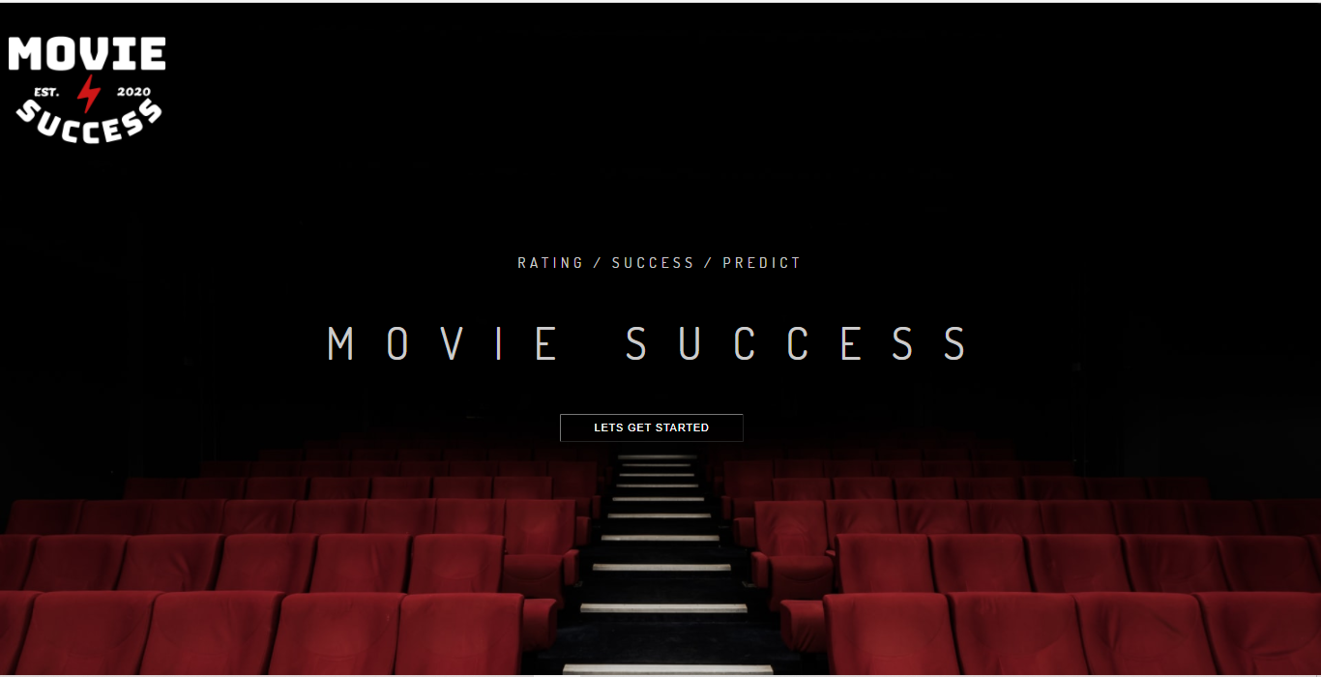

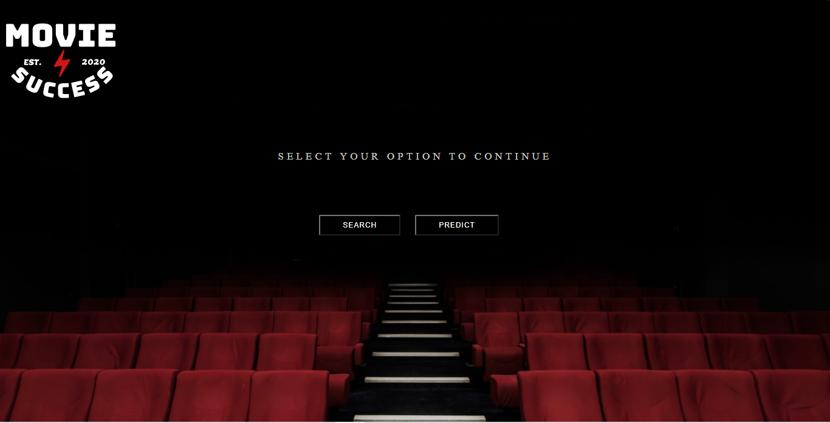

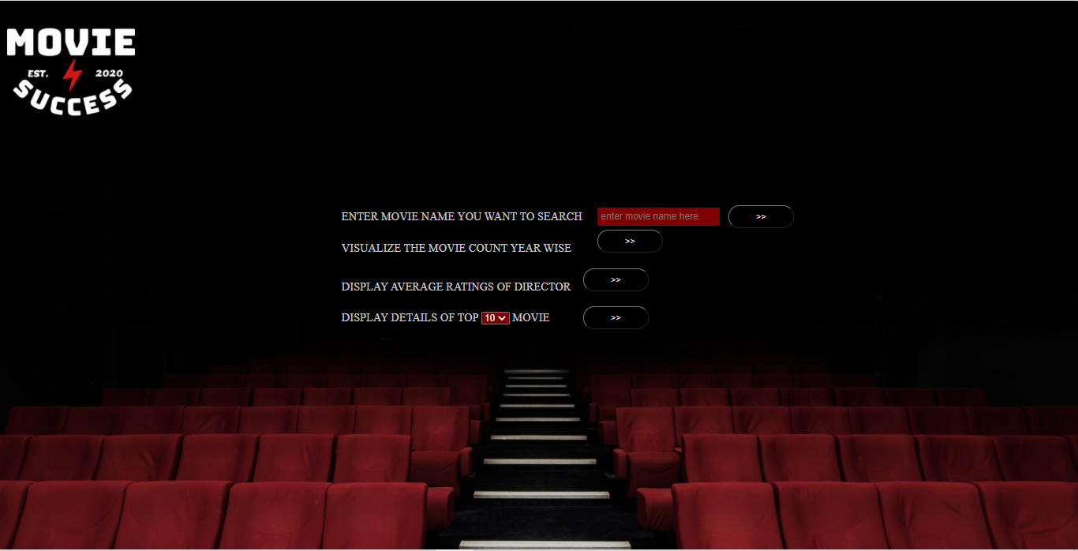

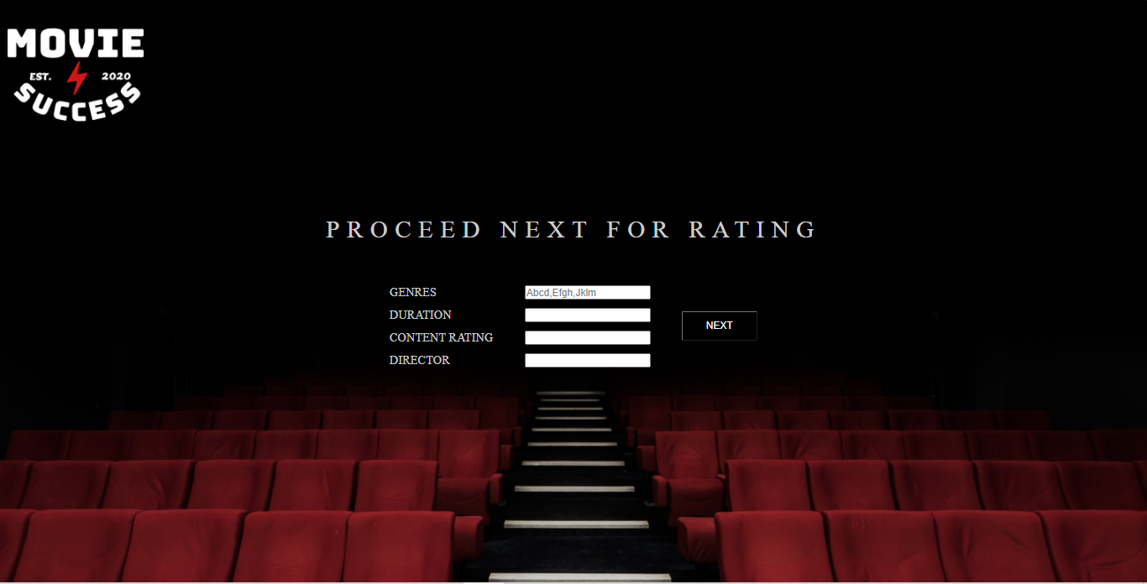

**OUTPUTS**

**Searching for movie name :**

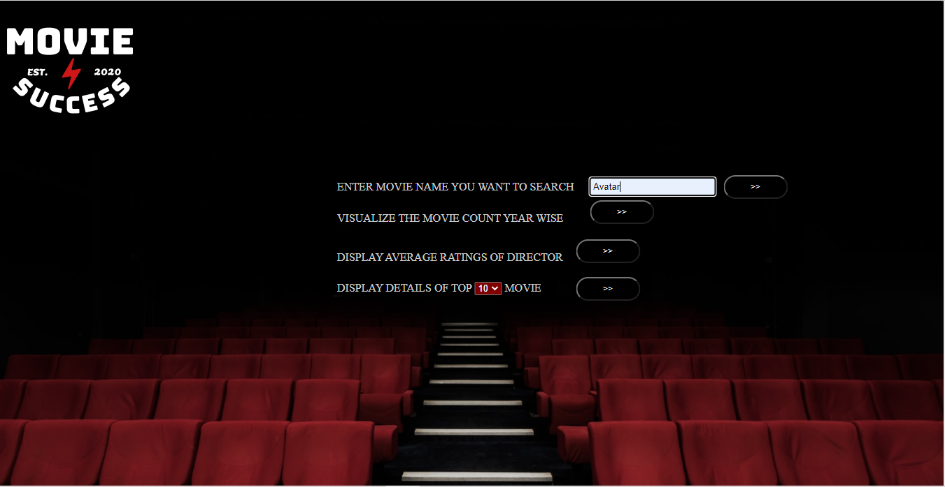



**Visualize the movie count year wise**

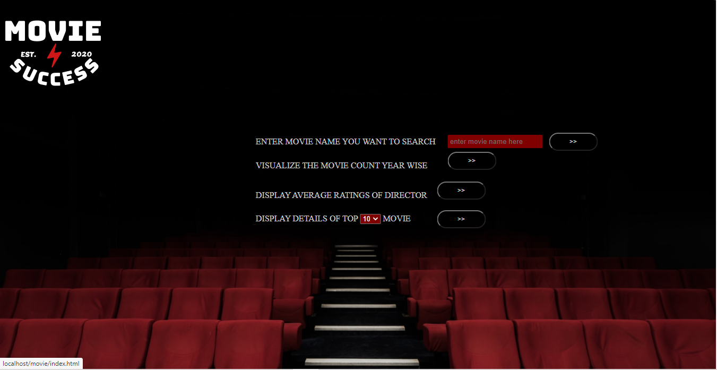

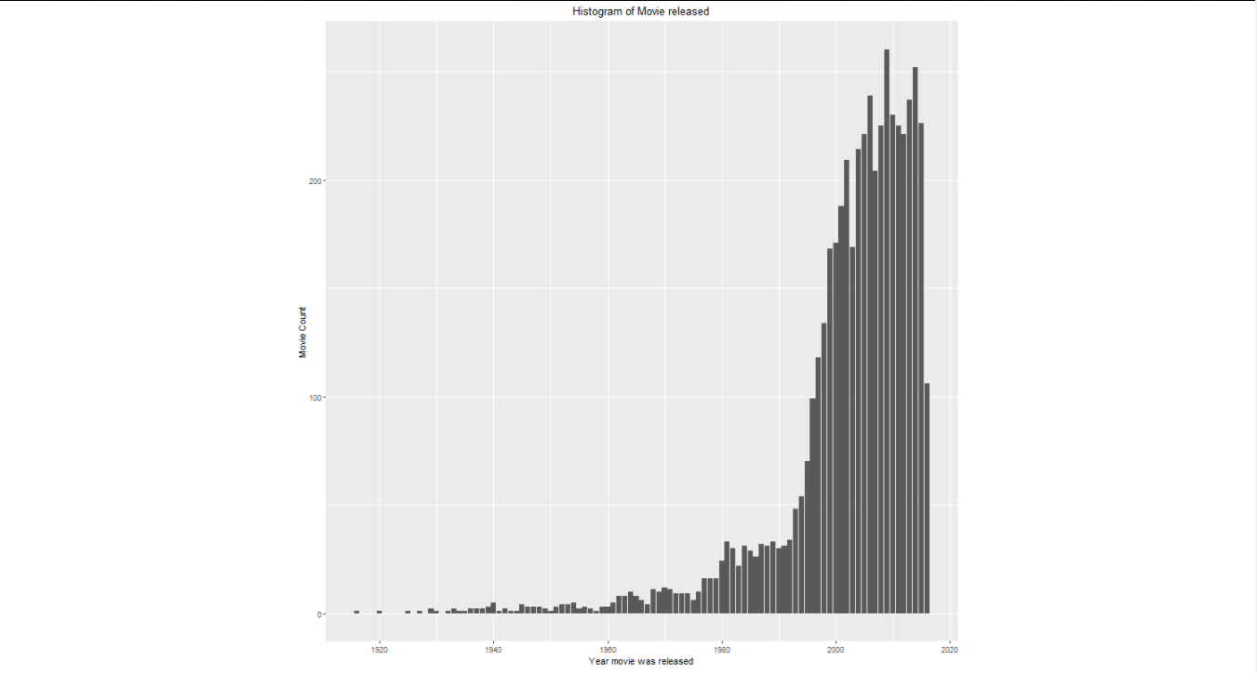

**Display average rating of Directors**





**Displaying Top few movies details**



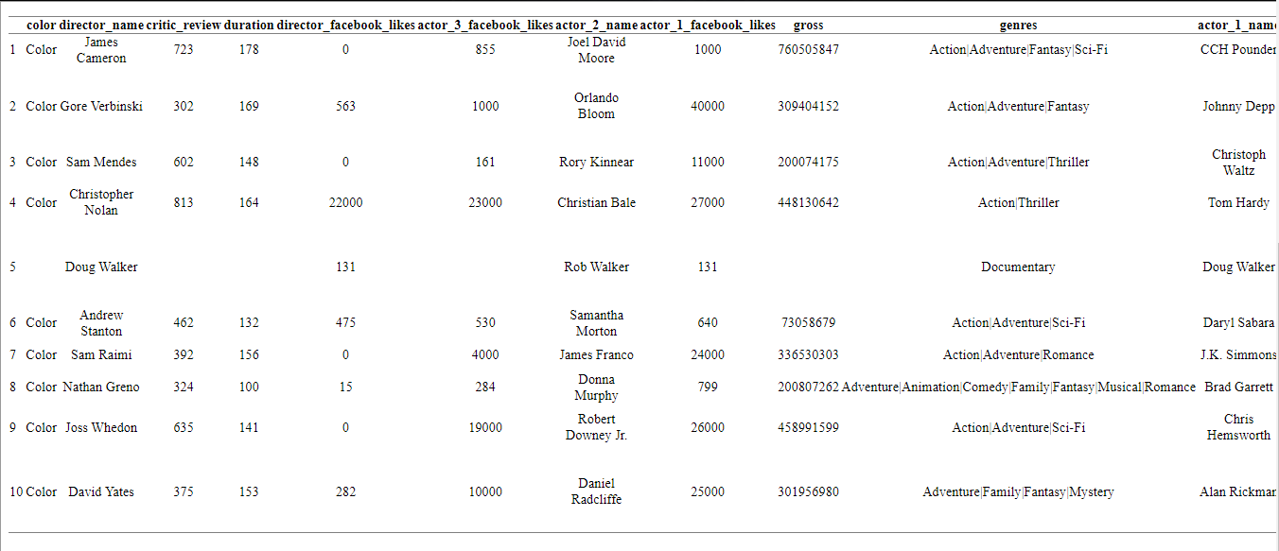

**Prediction of ratings**

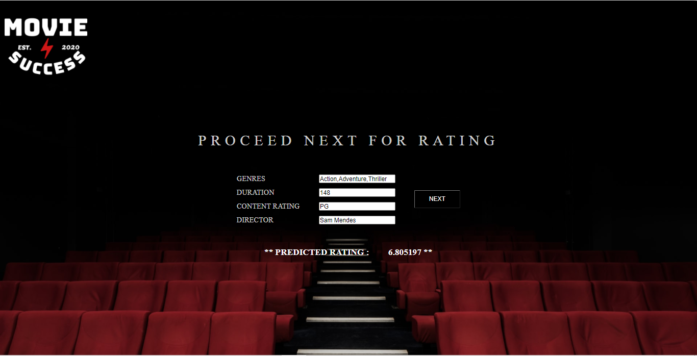

**Conclusion**

The intent of this study of creating a way to predicting the success of movies using historical data was not a direct success, it shows that other features are necessary to accurately make a prediction. When trying to predict the rating of a movie a highest success rate of around 65% achieved when using 6 groups and 83% when using 4 groups. This could arguably be a good enough result and shows promise, but when it is compared to previous studies with similar methodologies the result equal in predictability. When trying to predict the box office revenue of a movie a highest success rate of 15% was achieved, this result show that the method used in this study are difficult use for an accurate prediction, when compared to previous studies it shows that our method of preprocessing the data is not the best way to do it. When giving the model a binary decision of "will the revenue be greater than the budget" a success rate of around the high 60 percent was achieved. Therefore one can draw the following conclusion, using historical data to create a model to predict the rating of a movie shows promise and deserves to be properly evaluated. But then using the same historical data for trying to predict the box office revenue shows no promise using or method, previous studies have shown that it is possible to make accurate predictions, but the methods used in this study did not improve upon them.